# 1. Bar plot: CO2 emissions by route (Top 10)

top_routes = summary.head(10)

plt.figure(figsize=(12, 6))

sns.barplot(data=top_routes, x="route", y="co2_emissions", palette="Reds_d")

plt.xticks(rotation=45)

plt.title("Top 10 Routes by CO₂ Emissions")

plt.ylabel("CO₂ Emissions (tonnes)")

plt.xlabel("Flight Route")

plt.tight_layout()

plt.show()

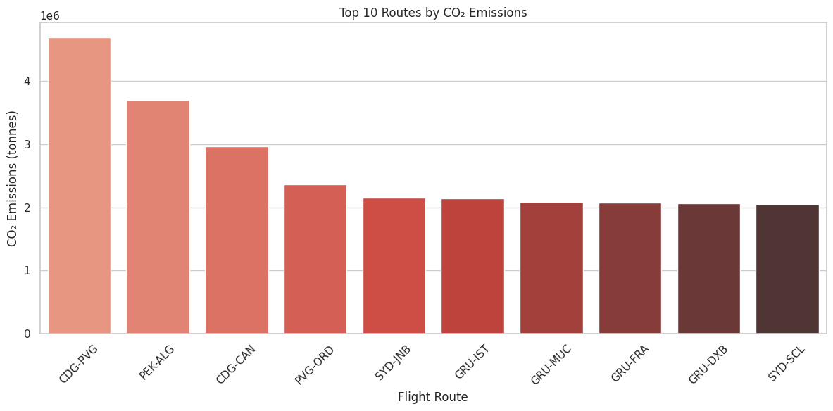

**# 2. Scatter plot: Wind effect vs CO2**

**plt.figure(figsize=(10, 6))**

**sns.scatterplot(**

**data=merged, x="tailwind_component", y="co2_emissions",**

**hue="crosswind_component", palette="coolwarm", size="co2_emissions", sizes=(20, 200)**

**)**

**plt.title("CO₂ Emissions vs. Tailwind (colored by Crosswind)")**

**plt.xlabel("Tailwind Component (km/h)")**

**plt.ylabel("CO₂ Emissions (tonnes)")**

**plt.tight_layout()**

**plt.show()**

